Confluence and Jira User Migration Preparation
Purpose: This document was created to help Confluence and Jira users understand and prepare components of their spaces and pages pre- and post-migration.
- See pages 3-4 for Migration Actions Summary charts, or
- Select an item from the Table of Contents below to access more detailed instructions.
Table of Contents
Confluence Migration Actions Summary Chart 2
Jira Migration Actions Summary Chart 3
Pre-Migration Instructions 4
Confluence – Personal Drafts 5
Post-Migration Instructions 5
Confluence – Children Display Macro – Child Depth Descendants 6
Confluence – Children Display Macro – Sort Order 6
Confluence – Comala Boards 8
Confluence – External Links to Confluence Spaces and Pages 9
Confluence – Personal Avatars 9
Confluence – Personal Spaces 10
Confluence – Space Shortcuts 10
Confluence – Team Calendars 11
Jira – Automation 12
Jira – Cross-Project Scrum and Kanban boards 12
Jira – Dashboards 13
Jira – External Links to Jira 13
Jira – Filters on non-migrating boards 13
Jira – Links to non-migrating issues or entities 14
Jira – Links to Jira or Confluence in text fields (details, comments, etc.) 14
Jira – Personal Avatars 14
Jira – Project Avatars 15
Jira – Scrum and Kanban boards not connected to a migrating project 17
Jira – Timesheet Gadgets 18
System Administrators Actions 18
Confluence – Internal Links using the Weblink Option 18
Jira – ProForma 18

Confluence Migration Actions Summary Chart
Feature/Functionality | Pre-Migration Actions | Post-Migration Actions
Children Display Macro | N/A | Edit the macro and increase child depth of descendants by 1. Edit the macro and choose Alphabetical in the Sort Order field.
Comala Boards | N/A | Recreate Comala boards in Cloud.
External links to Confluence | N/A | Manually reconfigure links to reference Cloud URLs.
Hyperlinks using the Web Link Option | System administrators are implementing a workaround. Nothing will need to be done by the end user.
Personal Avatars | N/A | Reassign personal avatars in Cloud
Personal Drafts | Publish any drafts you'd like to migrate. | N/A
Personal Spaces | N/A | Recreate personal spaces in Cloud.
Space Shortcuts | N/A | Recreate space shortcuts in Cloud.
Team Calendars | Export your team calendar. | Import your team calendar.

Jira Migration Actions Summary Chart
Feature/Functionality | Pre-Migration Actions | Post-Migration Actions
Automation (Group 2 only) | N/A | Recreate automation rules in Cloud.
Boards not connected to migrating projects | N/A | Recreate necessary Scrum and Kanban boards in Cloud.
Cross-Project Boards | N/A | Recreate cross-project boards in Cloud.
Dashboards | System administrators are currently testing a workaround.
External links to Jira | N/A | Manually reconfigure links to reference Cloud URLs.
Filters on boards that are not migrated | This depends on permissions. System administrators are working to learn more.
Links to issues or entities that are not migrated | No actions recommended. These will be available as read-only until October 2023.
Links to Jira or Confluence in text fields | N/A | Reconfigure links in comments or details fields to the new Cloud URLs.
Personal Avatars | N/A | Reassign personal avatars in Cloud.
Project Avatars | N/A | Reassign project avatars in Cloud.
ProForma (Group 2 only) | N/A, not available in Cloud | The system administrators are researching alternatives.
Timesheet Gadgets | N/A | Re-add timesheet gadgets to dashboards following migration.

Pre-Migration Instructions

Confluence – Personal Drafts
Personal drafts are unpublished pages in Confluence. These do not migrate to the Atlassian Cloud.
Instructions
- Select your personal avatar in the top right corner of the Confluence screen, and then select Drafts from the dropdown menu.
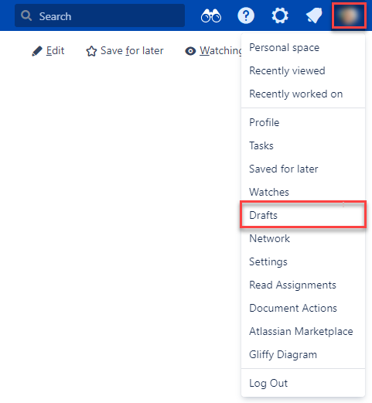
- Choose the Actions menu and choose to either Resume to open the page editor or Discard.
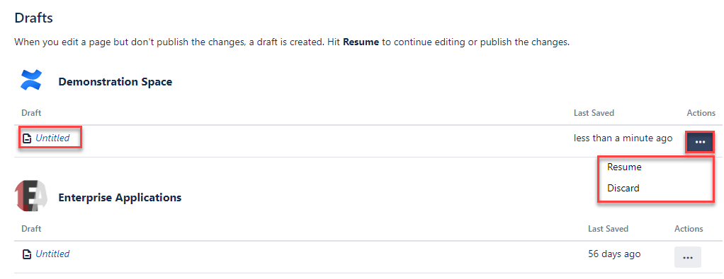
- Be sure to publish any pages you wish to migrate.

Post-Migration Instructions

Confluence – Children Display Macro – Child Depth Descendants
This macro is used to display a list of pages from a specific part of the page hierarchy.
This issue will appear as missing content in the content section of a main space page.
Instructions
Edit the macro and increase “Child Depth Descendants” by 1.
- Select the edit page icon or the keyboard shortcut “e”.
- Select the Child Display macro and select Edit on the macro menu.
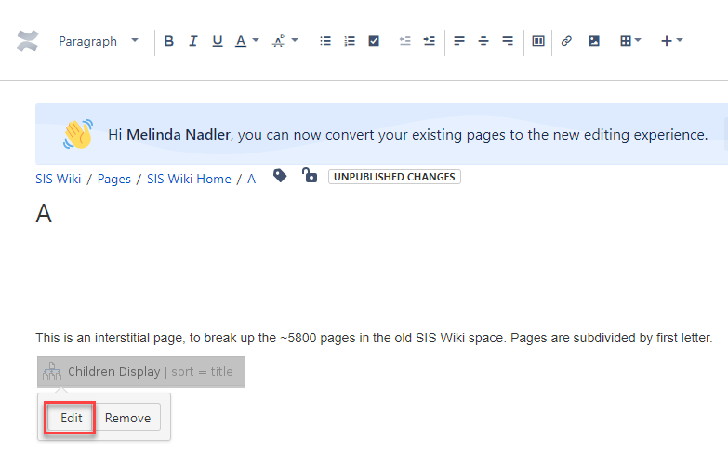
- Increase the “Depth of Descendants” field number by 1 in the left pane menu and select Save. Then select Publish in the page editor to see the corrected list.
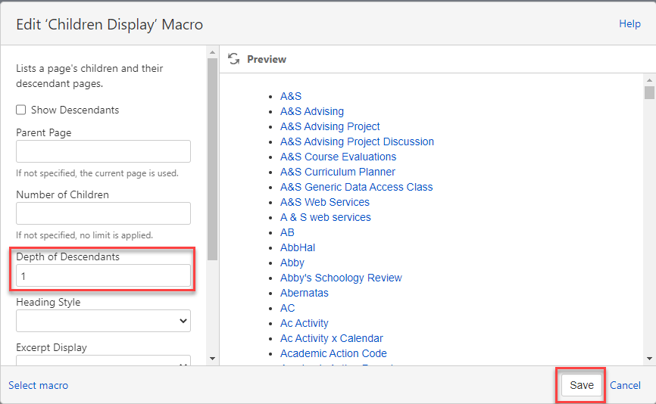

Confluence – Children Display Macro – Sort Order
This macro is used to display a list of pages from a specific part of the page hierarchy. The default sort order for Confluence child pages does not match the sort order in our legacy Confluence environment.
Below is an image of the child page sort order in our legacy environment. Special characters (i.e., &) are listed before alphabetic characters.
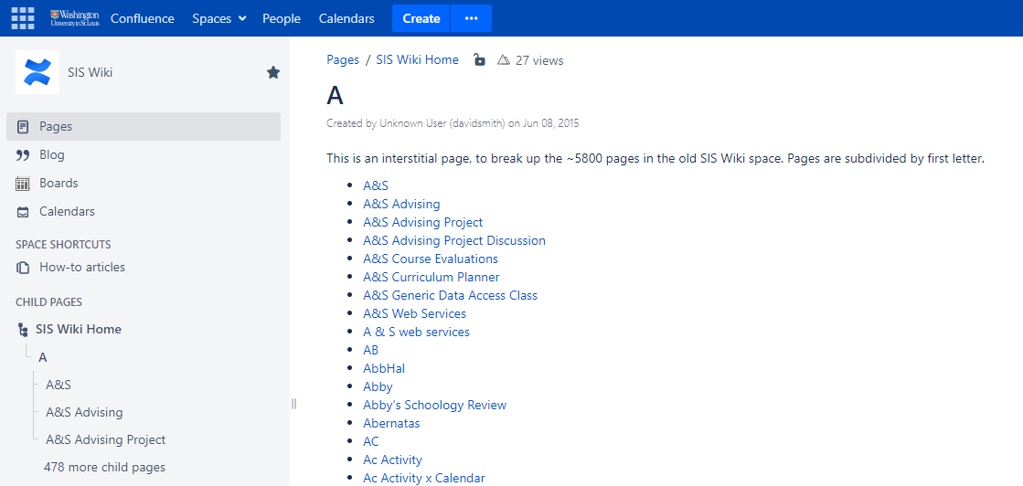
In the Atlassian Cloud, the default sort order lists special characters after alphabetic characters.
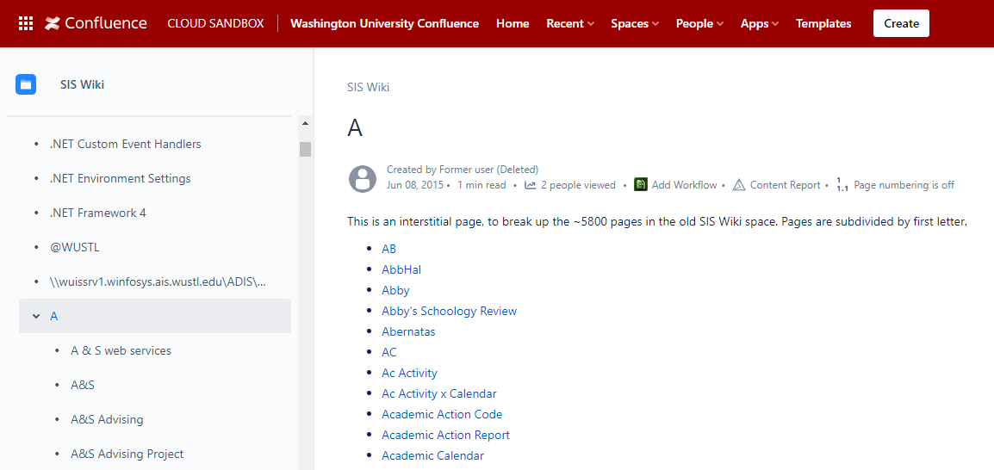

Instructions
Edit the Child Display macro to sort by Title.
- Select the edit page icon or the keyboard shortcut “e”.
- Select the Child Display macro and select Edit on the macro menu.
- Scroll down through the left pane menu to find “Sort Children By” and select title from the drop-down menu and select Save. Then select Publish in the page editor to see the corrected list.
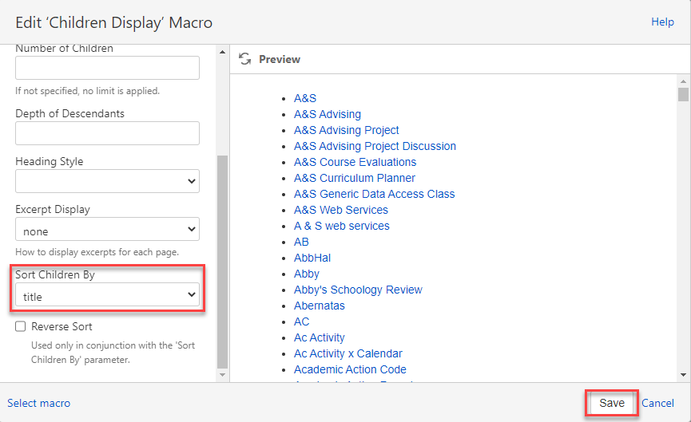

Confluence – Comala Boards
Comala boards are used as a visual method to brainstorming or managing your ideas using cards and linked pages. These do not migrate and will need to be recreated by users.
Instructions
Recreate Comala boards using Comalatech’s User Guide.

Confluence – External Links to Confluence Spaces and Pages
Space and Page URLs will change in the Atlassian Cloud. External links to Confluence Spaces and Pages will initially lead to the read-only legacy environment (eg. bookmarks, KnowledgeBase articles, etc.)
Instructions
Users will need to reconfigure external links to Confluence pages by replacing the legacy URL with the Cloud URL.

Confluence – Personal Avatars
Personal avatars are an optional feature in Confluence, allowing the user to customize their appearance in Confluence. The default avatar uses the user’s initials. These avatars do not migrate and will need to be re-assigned in the Cloud instance.
Instructions
- Select your user avatar (initials) in the top right corner of the screen in Confluence. Then select Manage Account.
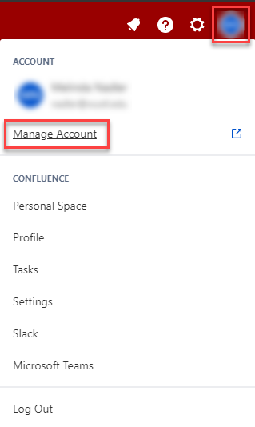
- The Profile and visibility screen will appear. Select the current avatar to open the avatar menu. Select Add profile photo and upload the avatar of your choice from your device.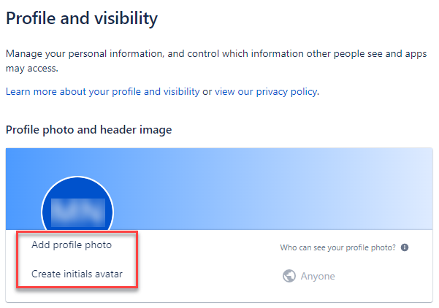

Confluence – Personal Spaces
A Personal Space serves a location to organize your notes and often serve as a dashboard for the user. Personal spaces do not migrate and will need to be recreated in Cloud by the user.
Instructions
Open both the legacy personal space and your new Cloud personal space in separate windows. Copy and paste relevant data to your new Cloud space.
Reference Atlassian’s Customize your Personal Space support page as needed.

Confluence – Space Shortcuts
Space shortcuts are links in the left pane menu to assist users of your space with navigation. Space shortcuts do not migrate to the Atlassian Cloud. Each space owner will need to recreate space shortcuts.

Instructions
- From the left-pane menu of a Space, select Add shortcut.
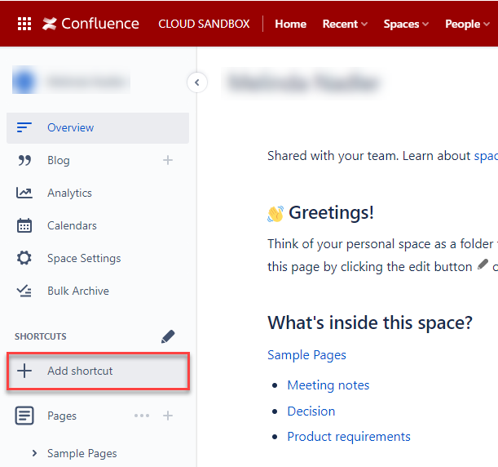
- Complete the required fields in the “Edit shortcuts” menu and select Save.
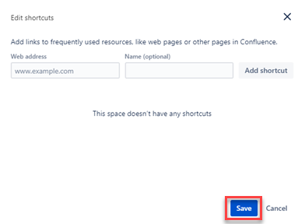

Confluence – Team Calendars
Team Calendars allows you to create calendars for yourself and your team, and view other calendars from your organization, all in one place. These do not migrate to the Atlassian Cloud and will need to be recreated or manually migrated by the user.
Instructions
To manually migrate the team calendar, users will need to export the team calendar as an .ics file and import that file to the Cloud instance. Refer to Atlassian’s How to Migrate Team Calendars data from Server to Cloud instructions for assistance.

Jira – Automation
Automation allows users to automate actions within their projects based on user-defined criteria. Automation rules do not migrate from Server to Cloud and will need to be manually recreated by the user. This only affects Group 2.
Instructions
Project owners can recreate the rules in the Cloud Sandbox environment and export/import automation rules from Sandbox into Production Cloud site after project has been migrated to Production. Import/Export will be executed by Jira Admin. This pertains only to Group 2 migration.
Refer to Atlassian’s Create and edit Jira automation rules support page for assistance.

Jira – Cross-Project Scrum and Kanban boards
Cross-Project boards are those that reference more than one project. These do not migrate to the Cloud and will need to be recreated in Cloud.

Image of a Cross-Project board:
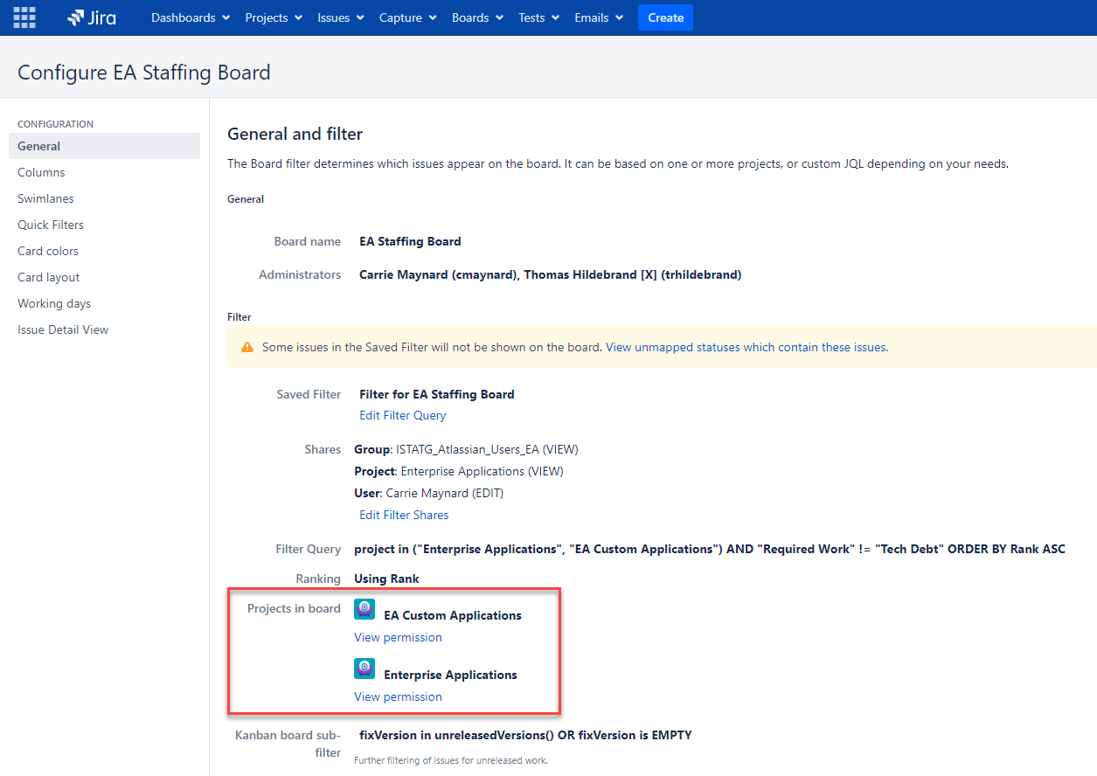
Instructions
Use Atlassian’s Learn how to create agile boards in Jira Software tutorial for assistance.

Jira – Dashboards
A dashboard is a display of gadgets used to help you organize your projects, assignments, and achievements in different charts. These do not migrate to the Atlassian Cloud.
Instructions
The system administrators are currently testing a workaround.
To recreate a dashboard in Cloud, refer to Atlassian’s Create and edit dashboards support page for assistance.

Jira – External Links to Jira
Project and issue URLs will change in the Atlassian Cloud. External links to Jira entities will will initially lead to the read-only legacy environment (eg. bookmarks, KnowledgeBase articles, etc.)
Instructions
Users will need to reconfigure external links to Jira entities by replacing the legacy URL with the Cloud URL.

Jira – Filters on non-migrating boards
Jira filters are saved searches that can be re-used. Filters connected only to non-migrating boards may not migrate depending on the permissions configuration.
Instructions
The project team is working to learn more.
Refer to Atlassian’s Save your search as a filter support page to learn more about creating, running, and managing your filters in Jira.

Jira – Links to non-migrating issues or entities
Any link in Jira referencing a non-migrating issue or entity will no longer work once the legacy instance of Jira is retired. These will be available as read-only until October 2023.
Instructions
There is no action necessary.

Jira – Links to Jira or Confluence in text fields (details, comments, etc.)
Any link in a Jira text field, such as the Description field or a comment referencing another Jira issue or entity, or a Confluence page, will need to be reconfigured in the Cloud environment.
Instructions
Users will need to manually replace relevant links in text fields.

Jira – Personal Avatars
Personal avatars are an optional feature in Jira, allowing the user to customize their appearance in Jira. The default avatar uses the user’s initials. These avatars do not migrate and will need to be re-assigned in the Cloud instance.
Instructions
- Select your user avatar (initials) in the top right corner of the screen in Jira. Then select Manage Account.
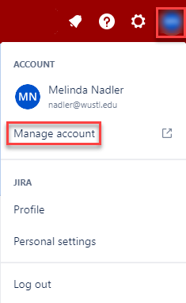
- The Profile and visibility screen will appear. Select the current avatar to open the avatar menu. Select Add profile photo and upload the avatar of your choice from your device.

Jira – Project Avatars
Project avatars are a feature in Jira that helps distinguish projects from one another. These avatars do not migrate and will need to be re-assigned by Project owners in the Cloud instance.
Instructions
- Select the Project Settings icon at the bottom of the left pane menu.
- Select Upload Image.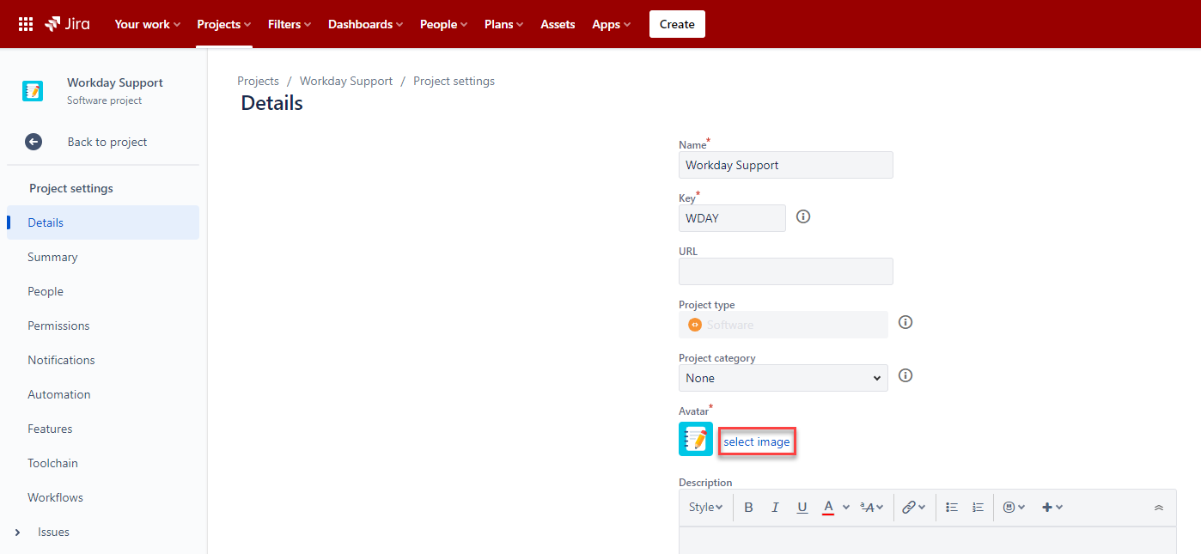

- Upload or select an existing avatar and select Close.
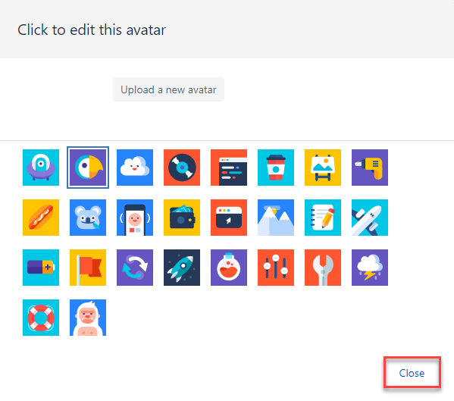
- Be sure to select Save details on the bottom of the Project Settings page to confirm your selection.
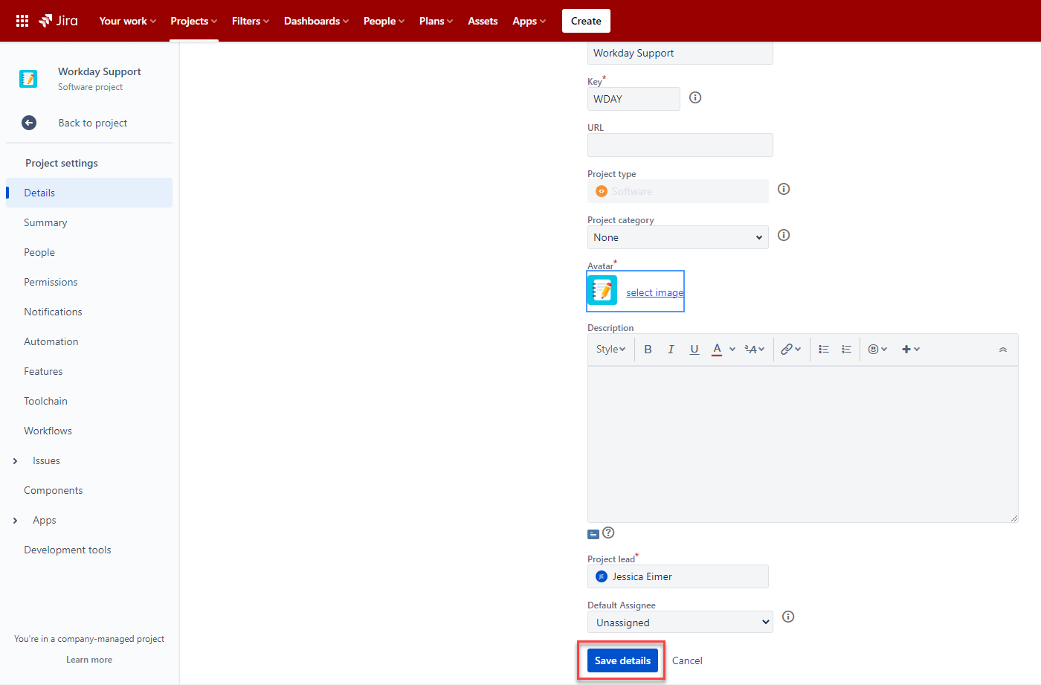

Jira – Scrum and Kanban boards not connected to a migrating project
Scrum and Kanban boards not connected to migrating projects will not migrate and will need to be recreated by the project owner in Cloud.
Instructions
Use Atlassian’s Learn how to create agile boards in Jira Software tutorial for assistance.

Jira – Timesheet Gadgets
This time reporting captures time spent on every project flow in Jira. Timesheet Gadgets do not migrate and will need to be recreated by Project owners in the Atlassian Cloud.
Instructions
Re-add Timesheet Gadgets to dashboards after your project has migrated.
Refer to Tempo’s Team Timesheet Gadget instructions for assistance.

System Administrators Actions

Confluence – Internal Links using the Weblink Option
Internal links are links within Confluence that refer to another Confluence page or space. There are three ways to insert a hyperlink in Confluence.
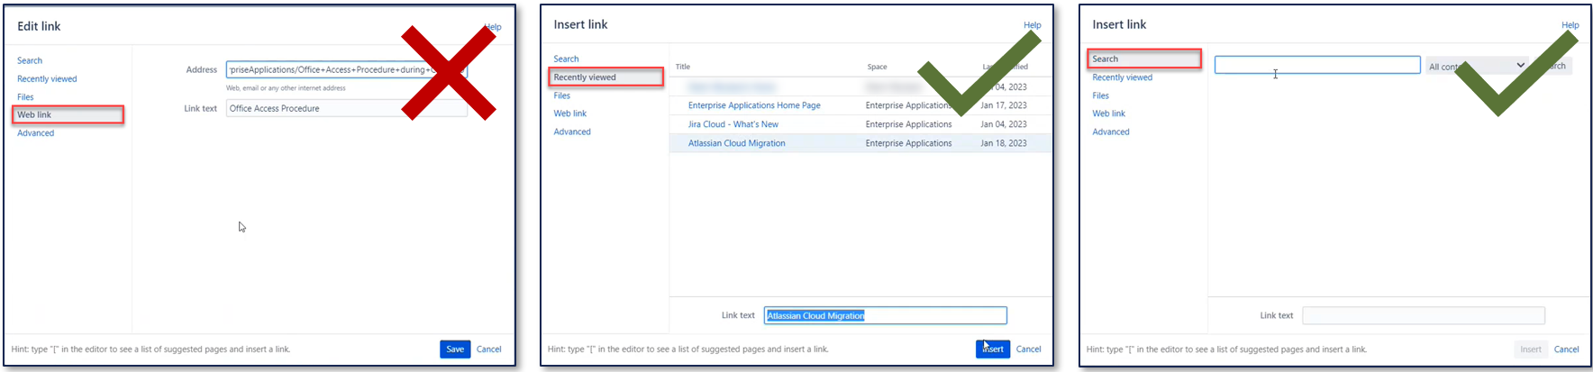
Hyperlinks created using the Web link option will not work in the Cloud instance, but those using the Recent and Search options will migrate since they employ macros.
Instructions
There is a project team workaround. Nothing will need to be done by the end user.

Jira – ProForma
ProForma is used to create forms within Jira issues or requests. These do not exist in Jira Cloud and will not migrate. This only affects Group 2.
Instructions
The system administrators are researching alternative options for use in place of ProForma and consulting with affected users.

